**Deploy the following on GCP using Google Python SDK :**

Note -  
1. Please use Python 3.x version  
2. Please tag all your resources - prefix=yourname-EmpID  
3. **You should implement logging in your scripts and store the logs in a separate log file**.

* 1. Write a python script to create a bucket in the region asia-southeast1
     1. Write a script to upload files to the created bucket

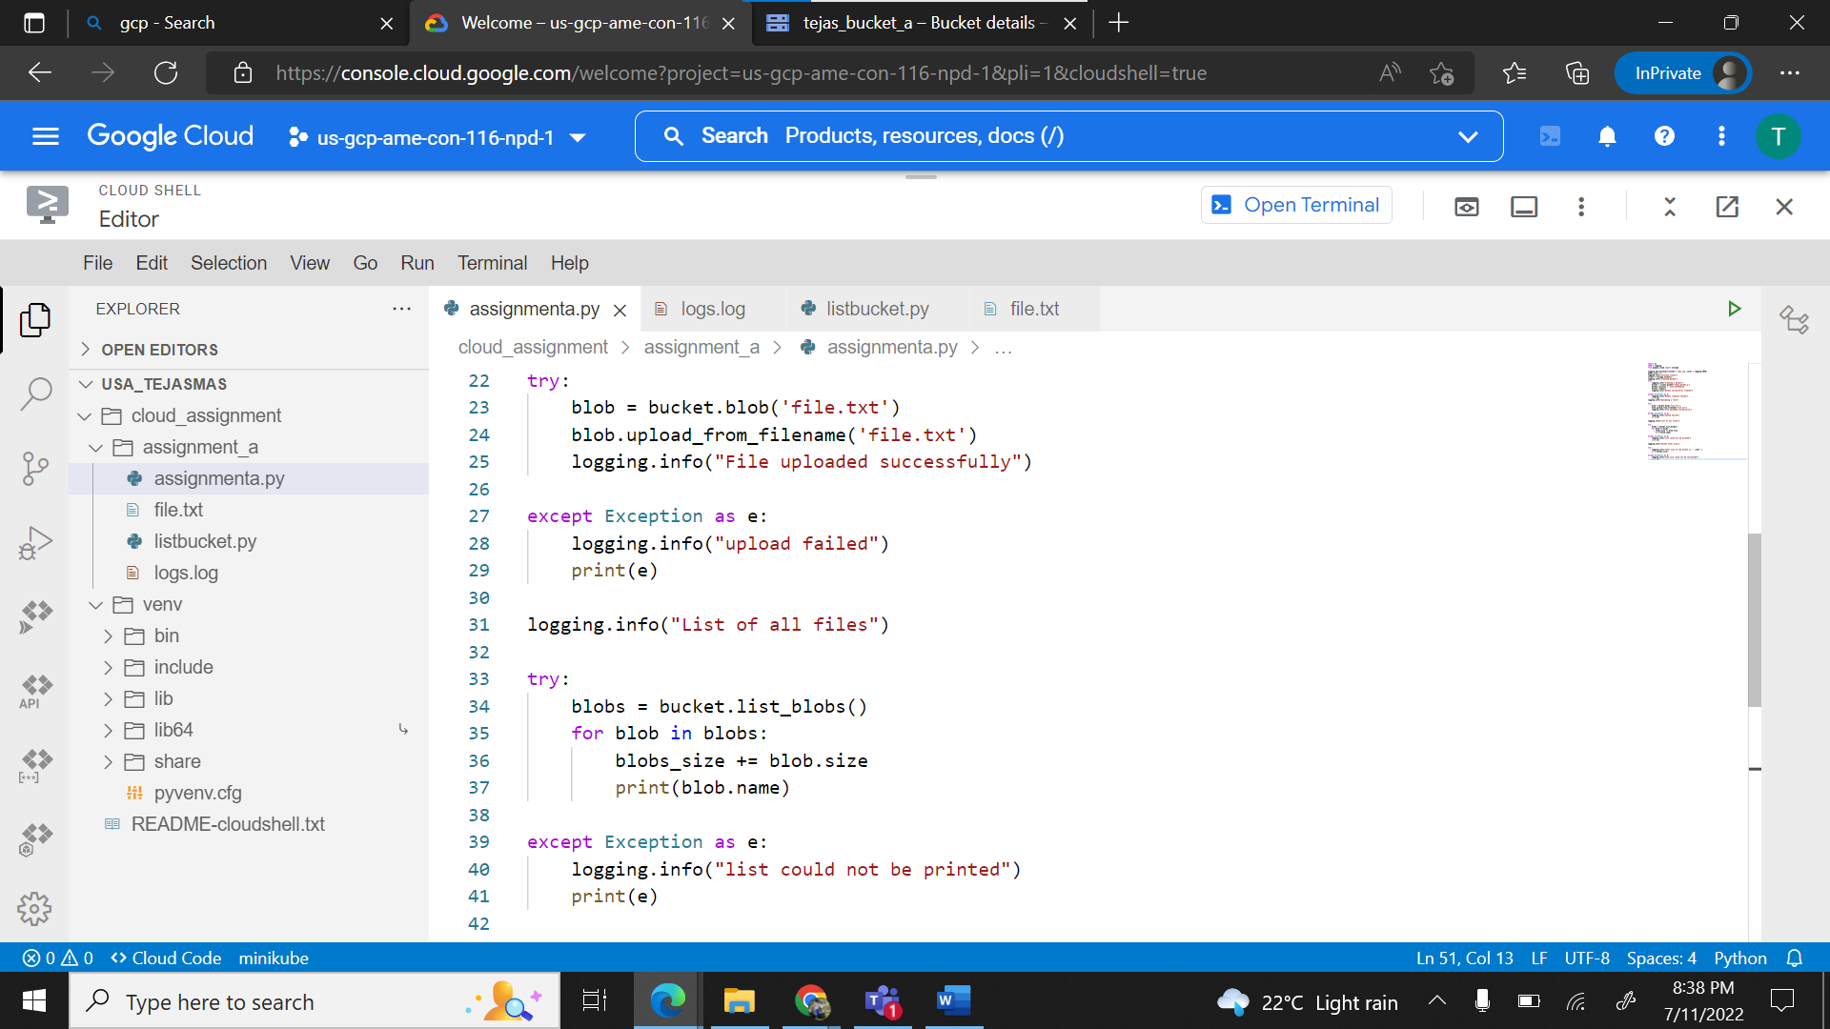

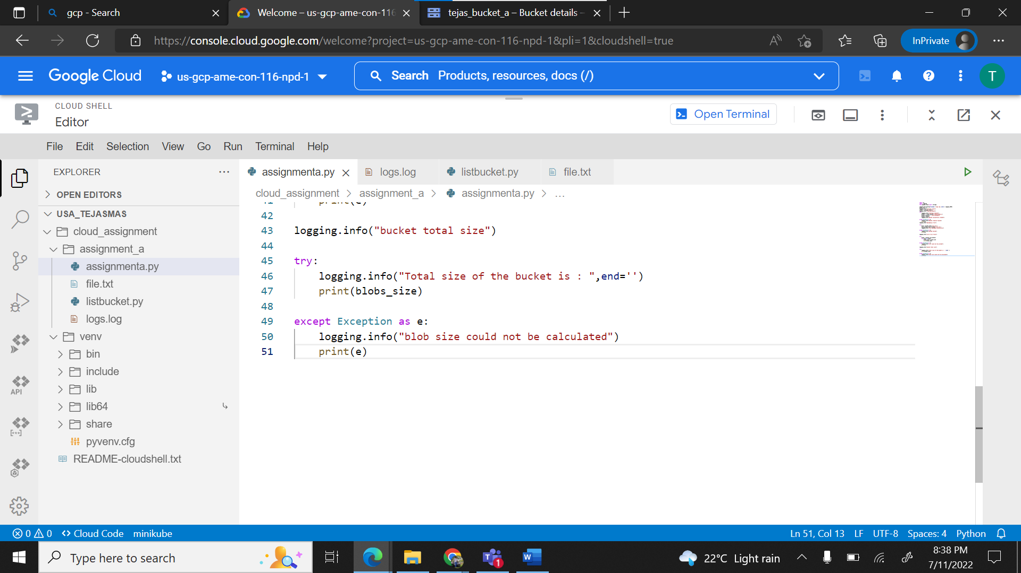

* + 1. Retrieve list of all the files available in the bucket

* + 1. Write a script to find the total size of the bucket

* 1. Write a python script to create a compute instance on the default network with tags

* 1. Write a python script to start/stop Instances based on Tags.

* 1. Write a python script to list the already existing service accounts and store the list output as a file to the Cloud Storage bucket you created in the previous question

* 1. Use gcloud CLI to list the VPCs, Subnets and Compute Engines in your project.,

* 1. Use gcloud CLI to create a Cloud Function which prints “Hello World”.

* 1. Write a python script that deletes everything you have created from these exercises. It should:
     1. Stop and Delete all instances
     2. Delete all Disks.

**Acceptance Criteria**

1. Provide Label and Tags to the resources created by you. There is no

evaluation for resources without Labels and Tags

2.Clean up the resource after finishing up the assignment and

evaluation.

3.Take screenshot of the resources provision and paste it to the document created by you. Push the document to your GitHub Repository

4.Be ready with your logins before coming for the evaluation

5.Please follow best practices in deployment/provisioning of resources.